[55958- Aman Goswami, Assignment-3, Date-12 Dec 2025]
Assignment- Create an infographic illustrating the Domain Driven Design (DDD) process. Highlight steps within it and a real-world use case
Domain-Driven Design (DDD) – Banking Application
Domain-Driven Design (DDD) is a software design approach where we focus on understanding the business domain first and then build software that follows the real-world banking rules.
“Learn how the bank works → break it into parts → create classes and rules that match the real system.”
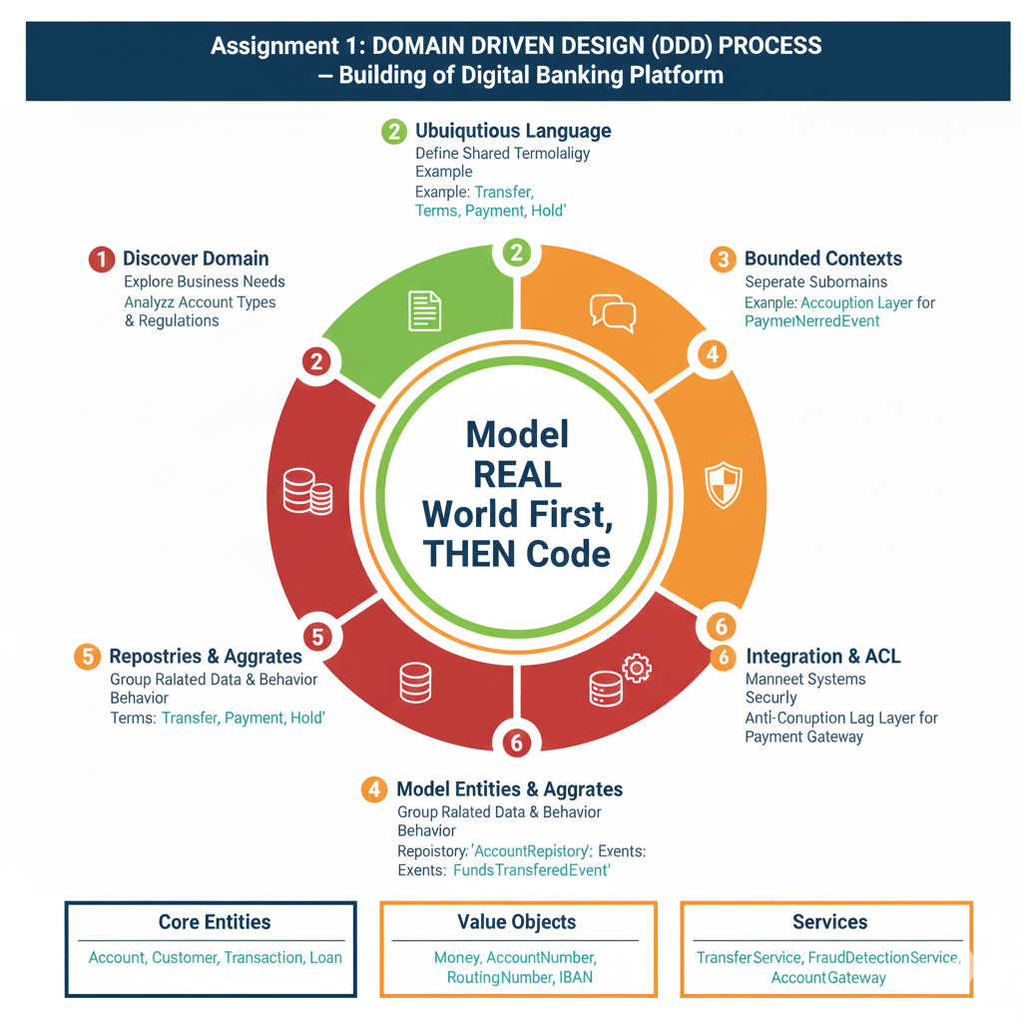
Steps of Domain Driven Design
- Discover the Domain
Understand how the business works by talking to experts.
- Create a Ubiquitous Language
Use one common vocabulary so everyone speaks the same terms.
- Identify Bounded Contexts
Break the big system into small modules like Accounts, Payments, and KYC.
- Model Entities, Value Objects & Aggregates
Create classes that represent real banking things (Account, Customer, Money).
- Define Repositories, Services & Domain Events
Write business logic (TransferService), events (PaymentCompleted), and storage rules.
- Integrate Using Anti-Corruption Layer (ACL)
Protect the system when connecting to external services like payment gateways.
Real-World Use Case: Bank Money Transfer System
Imagine you are building a “Transfer Money” feature for a bank.
How DDD helps:
- Discover Domain: Learn rules like “transfer cannot happen if balance is low.”
- Ubiquitous Language: Everyone uses the same words — Account, Transfer, Transaction.
- Bounded Contexts: Transfers happen in the Payments Context, balances in the Accounts Context.
- Entities:
  - Account stores balance
  - Transaction records transfer details
- Value Objects:
  - Money(amount, currency), AccountNumber
- Service:
  - TransferService checks balance, updates accounts, records transaction
- Event:
  - PaymentCompletedEvent after successful transfer
- ACL:
  - Payment gateway adapter connects with external systems safely
Result:
The money transfer works exactly like in a real bank — safely, clearly, and with proper rules.

